**Assignment -2**

|  |  |
| --- | --- |
| Assignment Date | 26 September 2022 |
| Student Name | Mr. P.Chandru |
| Student Roll Number | 612419104006 |
| Maximum Marks | 2 Marks |

**Question-1:**

1. Create a Flask App

2. Add the Home page, About Page

3. Add the Bootstrap

4. Add the Sign in page and App the Signup Page

|  |
| --- |
| **Solution:** |
|  |
| **app.py:** | from flask import Flask,render_template,request,url_for,redirect,flash  from markupsafe import escape  app=Flask(__name__)  @app.route("/")  def index():      return render_template("home.html")  @app.route("/home.html")  def hello():      return render_template("home.html")  @app.route("/about.html")  def profile():      return render_template("about.html")  @app.route("/signup.html")  def signup():      return render_template("signup.html")  @app.route("/signin.html")  def signin():      return render_template("signin.html")  @app.errorhandler(404)  def page_not_found(error):      return render_template('page_not_found.html'),404 |

**Templates:**

**Home page**

{% extends 'base.html'%}

{% block head %}

<title>home page</title>

{% endblock %}

{% block body %}

<main class="px-3">

    <h1>Cover your page.</h1>

    <p class="lead">hi you can signin here </p>

    <p class="lead">

      <a href="signup.html" class="btn btn-success">Signup</a>

    </p>

  </main>

{% endblock %}

**Base page**

<!DOCTYPE html>

<html lang="en">

    <head>

        <meta charset="utf-8">

        <meta name="viewport" content="width=device-width, initial-scale=1">

<link href="https://cdn.jsdelivr.net/npm/bootstrap@5.0.2/dist/css/bootstrap.min.css" rel="stylesheet" integrity="sha384-EVSTQN3/azprG1Anm3QDgpJLIm9Nao0Yz1ztcQTwFspd3yD65VohhpuuCOmLASjC" crossorigin="anonymous">

<script src="https://cdn.jsdelivr.net/npm/bootstrap@5.0.2/dist/js/bootstrap.bundle.min.js" integrity="sha384-MrcW6ZMFYlzcLA8Nl+NtUVF0sA7MsXsP1UyJoMp4YLEuNSfAP+JcXn/tWtIaxVXM" crossorigin="anonymous"></script>

<!-- <link rel="stylesheet" href="{{url_for('static', filename='css/style.css')}}"> -->

{% block head%}{% endblock %}

</head>

<body>

    <nav class="navbar navbar-expand-lg navbar-light bg-light">

        <div class="container-fluid">

          <a class="navbar-brand" href="#">Navbar</a>

          <button class="navbar-toggler" type="button" data-bs-toggle="collapse" data-bs-target="#navbarSupportedContent" aria-controls="navbarSupportedContent" aria-expanded="false" aria-label="Toggle navigation">

            <span class="navbar-toggler-icon"></span>

          </button>

          <div class="collapse navbar-collapse" id="navbarSupportedContent">

            <ul class="navbar-nav me-auto mb-2 mb-lg-0">

              <li class="nav-item">

                <a class="nav-link active" aria-current="page" href="home.html">Home</a>

              </li>

              <li class="nav-item">

                <a class="nav-link" href="signin.html">signin</a>

              </li>

              <li class="nav-item">

                <a class="nav-link" href="signup.html">signup</a>

              </li>

              <li class="nav-item">

                <a class="nav-link" href="about.html">about</a>

              </li>

              <li class="nav-item dropdown">

                <a class="nav-link dropdown-toggle" href="#" id="navbarDropdown" role="button" data-bs-toggle="dropdown" aria-expanded="false">

                  Dropdown

                </a>

                <ul class="dropdown-menu" aria-labelledby="navbarDropdown">

                  <li><a class="dropdown-item" href="#">Action</a></li>

                  <li><a class="dropdown-item" href="#">Another action</a></li>

                  <li><hr class="dropdown-divider"></li>

                  <li><a class="dropdown-item" href="#">Something else here</a></li>

                </ul>

              </li>

            </ul>

            <form class="d-flex">

              <input class="form-control me-2" type="search" placeholder="Search" aria-label="Search">

              <button class="btn btn-outline-success" type="submit">Search</button>

            </form>

          </div>

        </div>

      </nav>

    <div class="container mt-5">

        {% block body %} {% endblock %}

    </div>

</body>

</html>

**About page**

{% extends 'base.html'%}

{% block head %}

<title>about page</title>

{% endblock %}

{% block body %}

<main class="px-3">

    <h1>this the about page.</h1>

    <p>you will get it soon!!</p>

    <p class="lead">

      <a href="#" class="btn btn-lg btn-secondary fw-bold border-white bg-white">Learn more</a>

    </p>

  </main>

{% endblock %}

**Signin page**

{% extends 'base.html'%}

{% block head %}

<title>signin page</title>

{% endblock %}

{% block body %}

<h2>SIGNIN Forms</h2>

<form action="action_page.php" method="post">

    <div class="container">

      <label for="uname"><b>Username</b></label>

      <input  class ="form-control" type="text" placeholder="Enter Username" name="uname" required>

      <label for="psw"><b>Password</b></label>

      <input   class ="form-control"type="password" placeholder="Enter Password" name="psw" required>

      <button style="margin-top: 2ex;margin-left:50%"class="btn btn-success" type="submit">Login</button>

    </div>

    <div class="container" style="background-color:#f1f1f1;">

      <span>Forgot <a href="#">password?</a></span>

    </div>

  </form>

{% endblock %}

**Signup page**

{% extends 'base.html'%}

{% block head %}

<title>signup page</title>

{% endblock %}

{% block body %}

<h2>SIGNUp Forms</h2>

<form action="/action_page.php">

  <label for="fname">First name:</label><br>

  <input type="text" id="fname" name="fname" class="form-control"><br>

  <label for="lname">Last name:</label><br>

  <input type="text" id="lname" name="lname" class="form-control"><br><br>

  <input type="submit" value="Submit" class="btn btn-primary">

</form>

{% endblock %}

**Output**

**Homepage:**

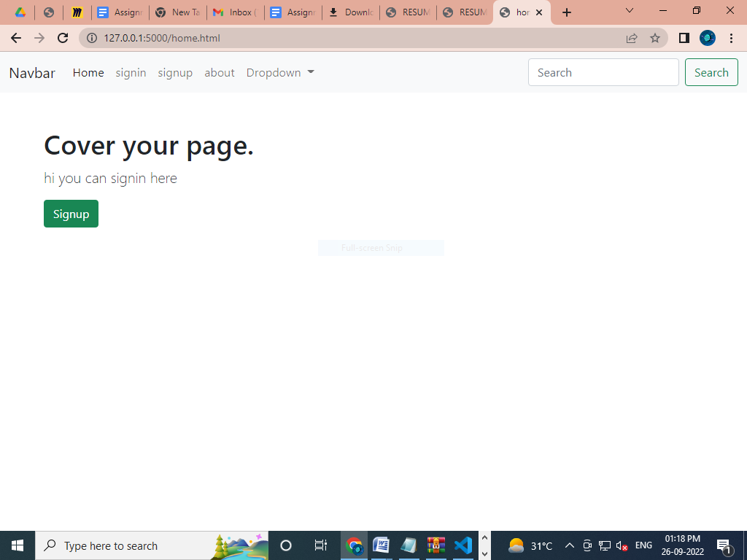

**Signin page:**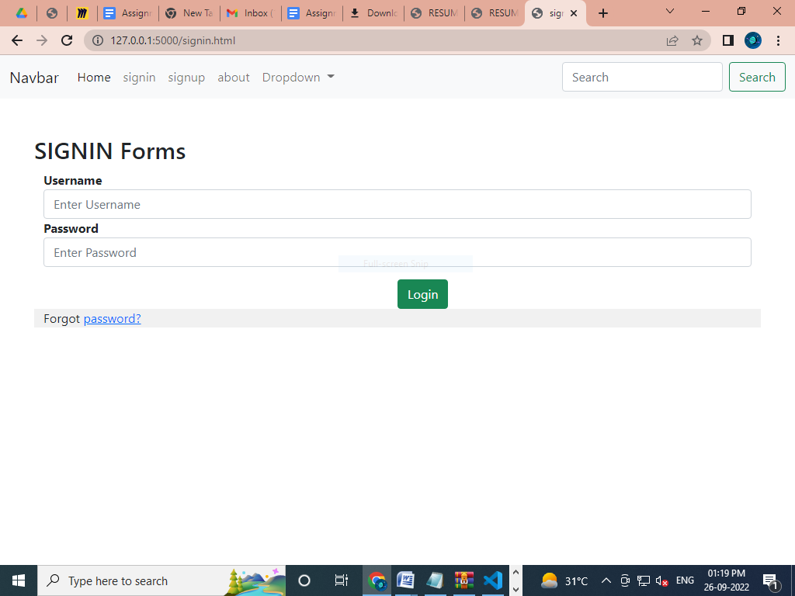

**signup page:**

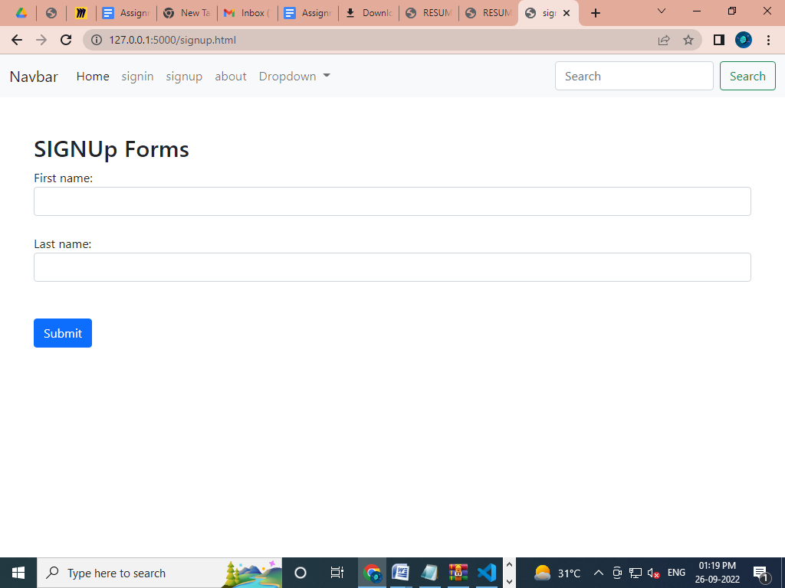

About page: